EDUCATIONAL QUIZ PLATFORM
@CREATIVITY THINK (9483175986/7019689991)

ABSTRACT:
Educational Quiz Platform is a web application designed to facilitate interactive learning and assessment for students, competitive exam aspirants, and training programs. Users can take timed quizzes, receive instant scoring and feedback, view leaderboards, and access detailed dashboard analytics. Administrators can create and manage quizzes and questions, moderate users, export statistics, and monitor participation through dashboards. Built using Django and Django Rest Framework for backend operations, and React, axios, and chart.js for frontend interactivity and analytics, the platform centralizes quiz management, automates scoring, and provides insightful performance metrics for learners and educators..

INTRODUCTION OF THE PROJECT:
Educational assessments are essential for tracking learning progress, but manual quizzes and evaluations are time-consuming and error-prone. The Educational Quiz Platform addresses these challenges by providing a web-based solution where learners can take quizzes, receive instant feedback, and view their performance on dashboards. Administrators can manage question banks, schedule quizzes, moderate users, and analyze results efficiently. The backend handles authentication, quiz logic, scoring, and leaderboard computation, while the frontend provides an interactive interface with real-time charts and analytics. This system enhances assessment efficiency and provides actionable insights for both learners and educators..

PROJECT OBJECTIVES:

• Provide a platform for interactive quizzes with timers
• Deliver instant scoring and feedback to users
• Maintain leaderboards for performance comparison
• Enable administrators to manage quizzes and question banks
• Moderate user participation and maintain secure access
• Export quiz statistics and performance reports
• Generate analytical dashboards for both users and administrators
• Ensure secure storage of quiz data, user information, and results

PROBLEM OF THE STATEMENT:
Traditional quiz and assessment methods often involve manual grading, delayed feedback, and limited performance tracking. This results in reduced learning engagement and inefficient administrative processes. Educational Quiz Platform resolves these issues by offering an automated system for creating, conducting, and evaluating quizzes online. Users get immediate feedback, while administrators can efficiently manage question banks, monitor participation, moderate users, export performance data, and view dashboard analytics. The platform enhances engagement, ensures fair assessments, and provides actionable insights for learning improvement..

MOTIVATION OF THE PROJECT:
• Simplify quiz-taking and assessment for students and learners
• Automate scoring, leaderboard updates, and feedback generation
• Centralize question bank and quiz management for administrators
• Provide detailed analytics to monitor user performance and trends
• Enhance engagement and learning outcomes through interactive quizzes

BLOCK DAIGRAM OF PROJECT:

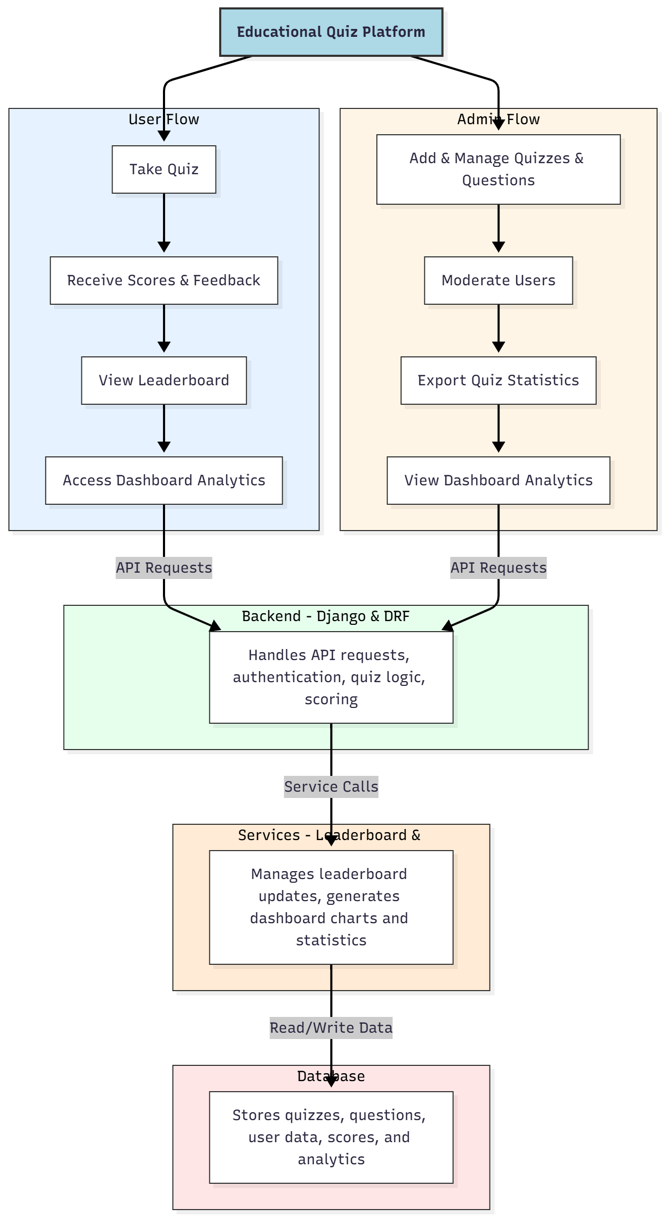

WORKING OF THE PROJECT:
Users start by taking quizzes based on predefined questions and timers. Upon completion, scores and feedback are immediately provided. Users can compare performance via the leaderboard and access detailed analytics on dashboards. Administrators create and manage quizzes, maintain the question bank, moderate user access, export statistics, and monitor dashboards. The backend handles authentication, quiz logic, scoring, and leaderboard calculations. Services generate analytics dashboards and update leaderboards dynamically. The database stores quizzes, questions, user profiles, scores, and analytics data, ensuring secure and efficient operations..

SOFTWARE REQUIREMENT:
- Backend:
  - Python 3.x
  - Django
  - Django REST Framework
  - SQLite/PostgreSQL
- Frontend:
  - Node.js and npm
  - React.js
  - Axios
- Development Tools:
  - Visual Studio Code
  - Postman (for testing APIs)
  - Git/GitHub (for version control)
- Server/Deployment (Optional):
  - Gunicorn, Nginx, or Heroku/AWS for hosting

ADVANTAGES OF THE PROJECT:

• Provides interactive and timed quizzes for learners
• Delivers instant scoring and feedback
• Maintains leaderboards to motivate competition
• Centralized quiz and question management for admins
• Moderates user participation and ensures secure access
• Generates PDF or dashboard statistics for performance tracking
• Enhances engagement and learning efficiency
• Supports analytics dashboards for performance insights

APPLICATIONS OF THE PROJECT:
• Schools and academic institutions for assessments
• Competitive exam preparation platforms
• Training centers and skill development programs
• Online learning and quiz-based evaluation portals
• Gamified learning systems with leaderboards
• Teacher/administrator dashboards for performance tracking
• Exportable analytics and performance reports
• User management and moderation for educational platforms

REFERENCES:

- Django REST Framework Documentation — Django Software Foundation. Django Documentation. Available: https://docs.djangoproject.com/
- Django REST Framework. DRF Documentation. Available: https://www.django-rest-framework.org/
- React. React Official Documentation. Available: https://reactjs.org/docs/getting-started.html
- Redux. Redux Documentation. Available: https://redux.js.org/introduction/getting-started
- PostgreSQL Global Development Group. PostgreSQL Documentation. Available: https://www.postgresql.org/docs/
- MySQL. MySQL Reference Manual. Available: https://dev.mysql.com/doc/
- Git. Git Documentation. Available: https://git-scm.com/doc
- Node.js. Node.js Documentation. Available: https://nodejs.org/en/docs/
- Axios. Axios Documentation. Available: https://axios-http.com/docs/intro
- Socket.io Documentation – https://socket.io/docs/

